Contact:

Katharina Aschhoff, M.Sc.
press@sigmasoft.de
+49-241-89495-1008
Kackertstr. 16-18
D-52072 Aachen

Press Release

Simulate Compression Molding for the First Time

Oldest Process Simulated with Newest Software

During Fakuma 2021, SIGMA Engineering presents the latest release of SIGMASOFT® Virtual Molding. Besides a further refined prediction of warpage and numerous enhancements for the calculation of multicomponent parts it contains the possibility to analyze compression molding processes for the first time. The development of this new simulation mode was accompanied by a close exchange of experiences with leading elastomer processors.

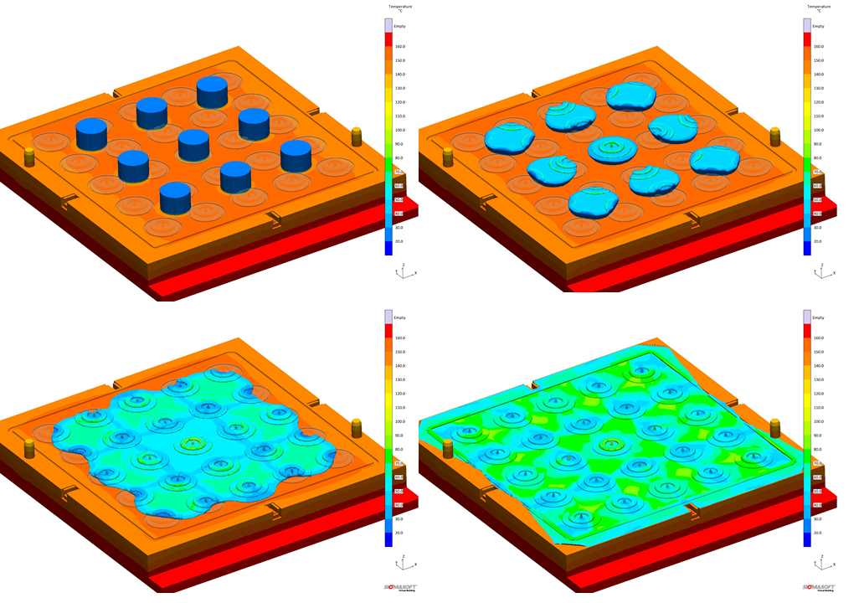
Picture 1 – 25 Cavities and 9 Preforms in a Compression Molding Process

Simulate Compression Molding for the first time

Aachen, October 7th, 2021 – During Fakuma (12.-16. October 2021) in Friedrichshafen, Germany, SIGMA Engineering GmbH presents new developments of SIGMASOFT® on Booth A5-5110. The new version 5.3.1 now allows the simulation of Compression Molding processes of rubber compounds.
Up to now, simulative design of mold and process was mainly focusing on modern injection molding technology. Since SIGMASOFT® is successfully introduced at many leading elastomer-molders, there was always a request to also implement the older processes, which remain technically required and/or cost-critical for manufacturing precision parts and O-rings, partly in small series. The simulation allows reliable prediction of curing degree and cycle-data. Questions around shape, weight, position and number of preforms can also be investigated. The quality of the molded parts can be optimized while reducing the material consumption, without time-consuming and costly trial-work.
„It sounds easy, but implementation was relatively complex“, explains SIGMA CTO Timo Gebauer: „The challenge is, that the cavity, or the room into which we inject, constantly changes during the closing of the mold. At the same time the inserted preforms are already heating up, are plasticizing and deforming. This development would not have passed the finish line without continuous advise and validation through our customers.“
Different to Thermoplastics, in the industry only few standardized elastomer compounds are available. Therefore, SIGMASOFT® features the creation of own material laws, based on internal or external measurements and supports users during implementation.
„It’s interesting, with this approach there is practically no remaining difference between Transfer and Compression Molding processes for the simulation. Technically, the injection sprue in the middle platen becomes part of the cavity. In the validation, we therefore also calculated Transfer Molding Tools successfully“, says Gebauer. „We are curious, how the most advanced simulation approach is accepted by the experienced rubber manufacturers for the oldest processes.”
SIGMASOFT® v5.3.1 not only includes the first possibility to simulate Compression Molding of Elastomers, but offers especially in the area of Thermoplastics numerous innovations and improvements for example a more precise prediction of warpage and shrinkage. The Autonomous Optimization feature included in the software now also works for 2 component parts. Additionally, the material data base was enhanced.

For 23 years, SIGMA Engineering GmbH has been driving the development of the injection molding process with its simulation solution SIGMASOFT® Virtual Molding. This virtual injection molding machine enables the optimization and development of plastic components and molds as well as the mapping of the entire production process. The SIGMASOFT® Virtual Molding technology combines the parts 3D geometries with its tooling and temperature control system and integrates the parameters of the production process. This ensures a cost-efficient and resource-saving production as well as high-performance products - from the first shot.
SIGMASOFT® Virtual Molding integrates a multitude of process-specific models including 3D simulation technologies that have been developed and validated over decades and are continuously optimized. The SIGMA Solution Service and Development team supports its customers technical goals with application-specific solutions. The software company SIGMA offers application engineering, training, direct software sales and as a result, a software straight from its developers and designers to help give a solution service by engineers all over Europe.
SIGMA Engineering GmbH, headed by Managing Director Thomas Klein, has subsidiaries in the USA, Brazil, Singapore, China, India, Korea and Turkey. In addition, SIGMA supports its users worldwide in a variety of international companies and research institutions with its Virtual Molding technology.
Further information: sigmasoft.de

This press information is available to download as pdf and doc format under the following link: https://www.sigmasoft.de/en/press/

